Two-level CSPro Applications

We recommend that two-level CSPro applications be avoided when possible. However, in some cases that is not possible. Here is an example of a “building” questionnaire: Building information followed by that for each household and its members in the building. It is important that the members be associated with the household as well as the building.

Building

Person #1

Person #3

Person #2

Person #1

In the above example we would want to process the records as follows:

Building information

Household #1 information

Person #1 information

Person #2 information

Person #3 information

Household #2 information

Person #1 information

In doing cross tabulations we want to be able to cross person characteristics with household characteristics. To do this the case cannot be treated as two house records and four person records. If crossing Building characteristics with Household or Person characteristics then this is appropriate.

There is no other reasonable way to treat this case except as a two-level application. We will define three record types: Building record, Household record, and Person record. Each case will have one record for building information followed by **nodes** for each household. This node consists of the Household record followed by a Person record for each member of the household.

**Topics**

* Information on each record
* Data dictionary items
* Data entry forms
* Entering data
* Data file

**Information on each record**

Here is the information that we are collecting:

Level Building [Building ID (HH ID = blank)] ---- **a case**

Record Building information

Type of roof

Type of water source

Number of HUs

Level Household [multiple] [Building ID + HH ID] ---- **a node in a case**

Record Household information

Telephone

Type of heat

Personal computer

Record Person information

Line number

Sex

Age

Marital status

**Data Dictionary items**

Here is the listing of the data dictionary:

Records in levels

-----------------------------------------------------------------------

Level Label Level Name

Record Label Record Name

-----------------------------------------------------------------------

two-level questionnaire TWO_LEVEL_QUEST

Building record BUILD_REC

Household HOUSEHOLD

Housing record HOUSE_REC

Person record POP_RECC

Items on records

Level: two-level questionnaire Record: Building record

------------------------------------------------------------------------------

Item Label Item Name Start

-------------------------------------------------------------------------------

(record type) 1

province (id) PROV 2

district (id) DIST 4

village (id) VILLAGE 6

enumeration area (id) EA 8

building number (id) BUILD 11

House number (id) HOUSE_NUMBER 14

Type of roof ROOF 17

Type of water source WATER 18

Number of HUs NUMBER_OF_HUS 19

Level: Household Record: Housing record

-------------------------------------------------------------------------------

Item Label Item Name Start

-------------------------------------------------------------------------------

(record type) 1

province (id) PROV 2

district (id) DIST 4

village (id) VILLAGE 6

enumeration area (id) EA 8

building number (id) BUILD 11

House number (id) HOUSE_NUMBER 14

Telephone TELEPHONE 17

Type of heat HEAT 18

Personal computer PC 19

Level: Household Record: Person record

-------------------------------------------------------------------------------

Item Label Item Name Start

-------------------------------------------------------------------------------

(record type) 1

province (id) PROV 2

district (id) DIST 4

village (id) VILLAGE 6

enumeration area (id) EA 8

building number (id) BUILD 11

House number (id) HOUSE_NUMBER 14

Line number LINE 17

Sex SEX 19

Age AGE 20

Marital status M_STATUS 23

Note: values are not listed for items to condense the listing.

**Data Entry form**

Sample Case Level Form [Building record]

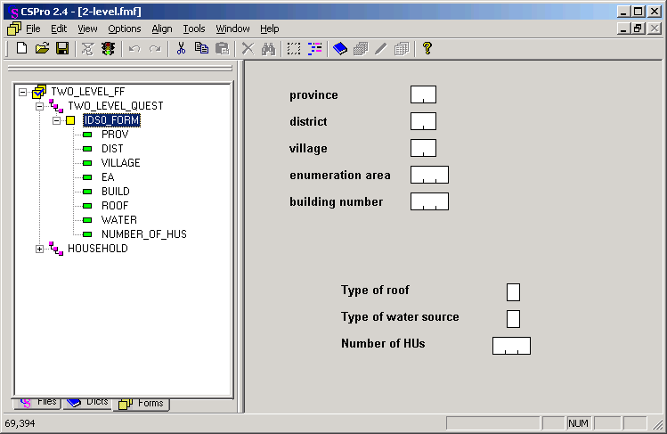

Sample Node Level Form [Household and Person records]

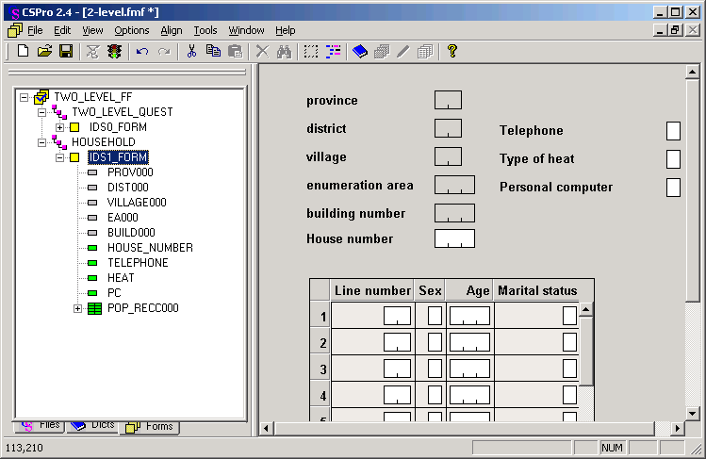

**Notes:**

There is NO ‘House number’ ID on the ‘case form’.

The ONLY ID on the ‘node form’ is the ‘House number’

**Entering data**

Data entry of the above example would be:

1. Enter data on ‘Case form’ [building ID + information] – ‘Accept’ writes to disk
2. Enter HH #1 data on ‘Node form’ [Household ID + information] – F12 to accept ‘node’ when completed; write to disk.
3. Enter HH #2 data on ‘Node form’ [Household ID + information] – F12 to accept ‘node’ when completed; write to disk.
4. Ctrl+F12 to complete case [ or you can Partial Save if allowed].

**Data File**

A test data file of two cases:

🡨 building ID 🡪<HH><- record data ->

ID

1010101001001 11001 <- building

2010101001001001111 <- household #1

30101010010010011121111<- person #1

31111010010010012111111<- person #2

31111010010010013220222<- person #3

2010101001001002222 <- household #2

30101010010010021222122<- person #1

1111101001002 22002 <- next building

2111101001002001111

31111010010020012220222

2111101001002002222